DEVELOPMENT OF A COMPUTER PROGRAM TO COMPUTE PAVEMENT THICKNESS AND STRENGTH

By:

Izydor Kawa
Galaxy Scientific Corporation
2500 English Creek Ave., Bldg. C
Egg Harbor Twp., NJ 08234-5562, U.S.A.
Phone: (609) 645-0900; FAX: (609) 645-2881
izydor.kawa@galaxyscientific.com

Gordon F. Hayhoe
FAA William J. Hughes Technical Center
Airport Technology Research and Development Branch, AAR-410
Atlantic City International Airport, NJ 08405, U.S.A.
Phone: (609) 485- 8555; FAX: (609) 485-4845
gordon.hayhoe@tc.faa.gov

PRESENTED AT THE 2002 FEDERAL AVIATION ADMINISTRATION AIRPORT TECHNOLOGY TRANSFER CONFERENCE

05/02

ABSTRACT

A computer program was developed for computing flexible and rigid pavement Aircraft Classification Numbers (ACNs) according to Annex 14 of the ICAO Airport Pavement Design Manual. The computer subroutines listed in Appendix 4 of the ICAO manual have been implemented in the computer program, and it was shown that these implementations accurately reproduce the ACNs computed by the ICAO programs. The program contains an internal library of aircraft covering most of the large commercial and military aircraft currently in operation and those included in the ICAO manual. A new aircraft configuration can be added to an external library. The user of the program can also modify airplane gear configurations by adding and removing wheels or moving wheels to any arbitrary location. The computer program also has the capability of calculating flexible and rigid pavement thicknesses. In the case of rigid pavements, calculation of slab thickness implements the Portland Cement Association (PCA) method based on slab interior stress or implements the Federal Aviation Administration (FAA) Westergaard edge stress procedure as is implemented in the design charts in Advisory Circular (AC) 150/5320-6D. Two triple twin tandems closely spaced were analyzed. It has been found that the influence of the second twin tandem on slab thickness is negligible based on the H51 model implemented in the computer program.

INTRODUCTION

Airport operators need a comprehensive tool for evaluation of pavement thickness and strength. COMFAA is a general-purpose computer program that operates in two computational modes: Aircraft Classification Number (ACN) Computation Mode and Pavement Design Mode. In ACN Computation Mode, COMFAA:

- Calculates the ACN number for aircraft on flexible pavements.
- Calculates the ACN number for aircraft on rigid pavements.
- Calculates flexible pavement thickness based on the California Bearing Ratio (CBR) method in Advisory Circular (AC) 150/5320-6D for default values of CBR of 15, 10, 6, and 3.
- Calculates rigid pavement slab thickness based on the Portland Cement Association (PCA) method for default values of k of 552.6, 294.7, 147.4, and 73.7 lb/in³.

In Pavement Design Mode, COMFAA:

- Calculates flexible pavement thickness based on the CBR method in AC 150/5320-6D for a CBR value specified by the user.
- Calculates rigid pavement slab thickness based on AC 150/5320-6D [2] for a k value specified by the user.

The above calculations can be done for any type of aircraft gear configuration. The user of the program can also modify airplane gear configurations by adding and removing wheels or moving wheels to any arbitrary location. The input data can be entered and results can be viewed in English and Metric units. This paper describes how the program was developed.

ACN NUMBER FOR FLEXIBLE AND RIGID PAVEMENTS

COMFAA contains two procedures for calculating the ACN number for rigid and flexible pavements, which are based on two Fortran computer programs adopted from the ICAO Aerodrome Design Manual [1]. Users may calculate the ACN number for any aircraft in the COMFAA library, which consists of internal and external libraries. The user has the capability to add aircraft only to the external library. The internal library consists of the following groups: generic, Airbus, Boeing, McDonnell Douglas, other commercial, and military aircraft groups. Overall, there are 90 types of aircraft available in the internal library.

Installation of THE RIGID PAVEMENT Design Model from AC 150/5320-6D

The following modifications were made to enable COMFAA to calculate rigid pavement thickness under a number of coverages of a design aircraft according to AC 150/5320-6D [2].

Installation of Visual Basic Version of H51

H51 [3] is a Fortran computer program which calculates slab edge stresses resulting from loads applied by aircraft landing gear. It is based on the theory of a semi-infinite plate on an elastic foundation. The H51 Fortran program was converted to Visual Basic, and the new program (TestH51) was thoroughly debugged to ensure that the results were the same as those from H51 within numerical roundoff. TestH51 was then installed into COMFAA and modified so that the aircraft characteristics may be read in from the aircraft library. All of the necessary input to TestH51 is provided by the COMFAA user through the COMFAA graphical interface.

Extension of H51 Capabilities

H51 has a capability to directly calculate slab edge stresses for the following gear configurations: single wheel, twin, dual twin (dual), single tandem, twin tandem, dual twin tandem, and triple twin tandem (tridem). However, the capability has been expanded to calculate the slab edge stress for any gear configuration using the principle of superposition.

The calculation of the slab edge stress σ_{A1}, for a wheel located at coordinates x and y, is accomplished in the following steps as shown in figure 1:

- Calculate the slab edge stress σ_{A2} for a twin tandem with x-transverse spacing between the tires, and y-longitudinal spacing between the tires.
- Calculate the slab edge stress σ_{A3} for a single tandem with y-longitudinal spacing between the tires.
- Calculate the slab edge stress σ_{A4} for a single wheel displaced a distance x from the point of calculated stress.
- Calculate the slab edge stress σ_{A1} for a wheel located at coordinates x and y according to the formula σ_{A1} = σ_{A2} - σ_{A3} - σ_{A4.}

For gear configurations not included in H51, COMFAA performs stress calculations for all of the individual wheels of the gear. The final slab edge stress from the gear is calculated by the summation of all of the stresses produced by the individual wheels.

-
-
=
y
x
x
y
x
y
σ_{A2}
σ_{A3}
σ_{A4}
σ_{A1}

Figure 1. Calculation of slab edge stress for any wheel location using the principle of superposition.

Initially, the location of maximum stress is not known and can be located either under one of the wheels or at some location between the wheels. A subroutine was written based on a golden section search procedure [4], which searches for the maximum stress along the slab edge. Two cases were analyzed, as shown in figure 2. First, when a gear is located perpendicular to the slab edge, the search is conducted along the x-axis between points “A” and “B.” Second, when a gear is located parallel to the slab edge, the search is conducted along the y-axis between points “C” and “D”.

y

“D”

“C”

x
“A”
“B”

Figure 2. Search area for maximum stress location.

Calculation of Slab Thickness

The calculated maximum slab edge stress for a specified slab thickness is compared with the maximum allowable stress specified for the PCC. If the calculated maximum stress is significantly different from the maximum allowable stress, the slab thickness is adjusted. For example, the Federal Aviation Administration (FAA) computer program for rigid airport pavement design R805FAA uses an approximation method to estimate PCC slab edge stresses and obtains PCC slab thickness by an iterative method. A review of the source code for R805FAA shows that the obtained thickness is then adjusted by a coefficient which is calculated based on the number of aircraft coverages. This represents the PCC fatigue failure model. A similar approach was used in a subroutine of COMFAA, the difference being that the subroutine uses the H51 code for calculating slab edge stresses. The purpose of this subroutine is to find the slab thickness, H_{Slab}, for which the slab edge stress, calculated by COMFAA, satisfies the following equation:
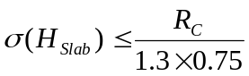 (1)
where:
σ(H_{Slab}) | = maximum tensile edge stress at the bottom of the slab for slab thickness H_{Slab}
R_{C} | = flexural strength of the PCC
1.3 | = safety factor
0.75 | = reduction factor based on assumption that a joint transfers 25% of the load to the other side of the joint

The slab edge stresses are calculated for gear loads located either parallel or perpendicular to the joint. From the two calculated stresses the maximum stress is selected which satisfies Equation 1. A procedure, RTBIS [4], implementing a bisection method, was translated to Visual Basic to find the slab thickness H_{Slab} for which the maximum slab edge stress σ is calculated by COMFAA with the precision of 0.01 in. Figure 3 presents a flow chart for the algorithm implemented in COMFAA.

Initially, the algorithm determines a slab thickness interval within which the solution exists. It then starts a loop. The maximum slab edge stress is evaluated in the middle of the interval. If the maximum stress is higher than the maximum allowable stress, a new interval is taken between the midpoint and the upper bound of the interval and the stress is evaluated at the midpoint of the new interval HSlab = HSlab + DH, where DH is half the distance between HSlab and the upper bound of the interval. If the maximum stress is lower than the maximum allowable stress, then the new interval is taken between the lower bound of the interval and the midpoint, and the stress is evaluated at the midpoint of the new interval HSlab = HSlab – DH, where DH is half the distance between HSlab and the lower bound of the interval. The loop continues until the size of the interval is smaller than 0.01 inch. Finally, the slab thickness, H_{Slab}, is adjusted by a factor α as applied in the following equation:

 (2)

where α is a function for adjusting slab thickness by using the fatigue curve developed by the U.S. Army Corps of Engineers from test track data and observations of in-service pavements calculated according to the following equations [5]:

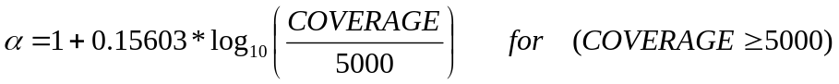 (3)
or
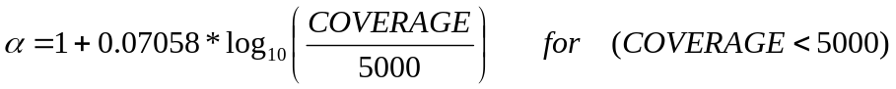 (4)

Determine interval in which the solution exists (H1, H2 = H1+DH)

HD = 0.5 * DH

H_{Slab} = H1 + DH

DH = DH * 0.5

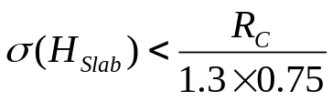

False
True

HSlab = HSlab + DH
HSlab = HSlab - DH

DH < 0.01

True
FALSE
Finish

Figure 3. Algorithm for calculating slab thickness.

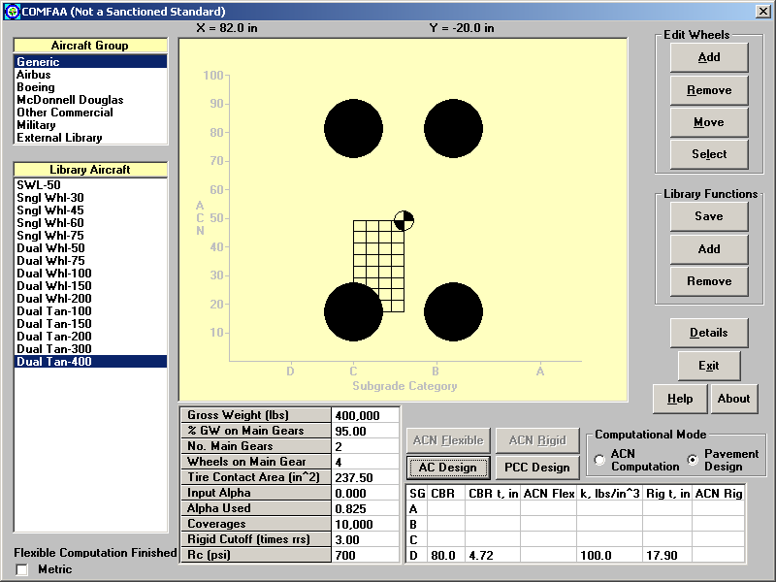

Figure 4. COMFAA graphical interface with design thickness result.

Figure 4 presents a COMFAA screen with a design thickness result. COMFAA runs calculations for rigid pavements in two different computational modes:

- The ACN Computation Mode: ACN calculations and slab thickness calculations based on the slab interior stress as specified in reference 1.
- The Pavement Design Mode: slab thickness calculations that implement the FAA procedure based on Westergaard edge stress as is implemented in the design charts in AC 150/5320-6D [2].

The user selects the computational mode by selecting the option button in the computational mode frame as shown in figure 4. When the user selects the option button labeled “ACN Computation” and clicks the button labeled “ACN Rigid,” PCC slab thicknesses and ACNs are calculated for four pavement structures having subgrades with the specified k values (552.6, 294.7, 147.4, and 73.7 lb/in³). The calculations are based on the slab interior stress.

If the user selects the option button labeled “Pavement Design” and clicks the button labeled “Rigid Design,” the program computes PCC slab thickness for the k value specified by the user and based on the slab edge stress. The user specifies the k value by clicking on the field labeled “k lb/in^3” and typing the k value in a message box.

For the case shown in figure 4, the design thickness of the slab is 17.90 inches on a subgrade with a k value of 100 lb/in³ and loaded with a 400,000 lb dual tandem gear aircraft and 10,000 coverages, in which coverages may be obtained from the total pass number divided by the pass/coverage ratio in AC 150/5320-6D [2].

Reliability of COMFAA

The reliability of COMFAA was checked with respect to the calculation of ACNs, slab edge stress, and slab thickness.

ACNs Calculated Using the ComFAA, ACNR, and ACNF Programs

The results are presented in Tables 1 and 2 and show that for some airplanes there are minor differences between ACNs calculated by COMFAA and those obtained from the ICAO Design Manual. These differences could be attributed to rounding of the ACNs in the ICAO Design Manual. A comparison with programs ACNR and ACNF [6 and 7], which are two computer programs developed based on the ICAO Design Manual [1], was made to check for similar differences. For most of the gear configurations that can be classified as single, dual, tandem, and dual tandem, the differences between the ACNs calculated by COMFAA and those listed in the ICAO Design Manual are very small. In most cases, ICAO ACNs look like rounded numbers calculated by COMFAA. For example, for flexible pavement (subgrade CBR=15), the COMFAA for the A310 aircraft is 35.9, the ICAO number is 36, and the ACNF number is 35.80. This indicates that the ACN calculated by ACNF supports those calculated by COMFAA. Therefore, the ACN calculated by COMFAA can be considered reliable and the program can be used for the calculation of ACNs for the gear configurations which can be classified as single, dual, tandem, and dual tandem.

For the more complex gear configurations, COMFAA ACNs are either similar to ICAO ACNs and/or to ACNF ACNs or ACNR ACNs, except for the Canadair CL 44 aircraft for rigid pavements. For the Canadair CL 44 aircraft on rigid pavements, the ICAO and the ACNR ACNs are similar. However, ACNs calculated by COMFAA are higher. The difference needs further study.

Table 1. ACNs for selected aircraft on rigid pavements.
Aircraft type | ACN by COMFAA  Subgrade k [MN/m³] |  |  |  | ACN by ICAO Design Manual Subgrade k [MN/m³] |  |  |  | ACN by ACNR [6]  Subgrade k [MN/m³]
 | 150 | 80 | 40 | 20 | 150 | 80 | 40 | 20 | 150 | 80 | 40 | 20
A310 | 32.4 | 38.7 | 46.2 | 53.2 | 33 | 39 | 46 | 54 | 33 | 38.4 | 45.4 | 52.3
A320 DT | 16.5 | 19.8 | 23.6 | 27.2 | 18 | 21 | 24 | 28 | 16.7 | 19.7 | 23.3 | 26.9
Caravelle 10 | 13.7 | 16.4 | 19.3 | 21.9 | 15 | 17 | 20 | 22 | 32.8 | 33.7 | 34.7 | 35.6
Canadair CL 44 | 30.0 | 35.2 | 40.6 | 45.4 | 25 | 30 | 35 | 40 | 25.3 | 29.9 | 35.4 | 40.5
CV 880 M | 25.8 | 30.8 | 35.8 | 40.3 | 26 | 31 | 36 | 41 | 25.7 | 30.0 | 34.9 | 39.3
MD-87 | 43.7 | 46.0 | 48.0 | 49.7 | 45 | 47 | 49 | 50 | 43.7 | 46.0 | 48.1 | 49.7
DC-10-15 | 48.5 | 57.2 | 68.5 | 79.7 | 48 | 56 | 67 | 74 | 48.7 | 56.3 | 67.0 | 78.0
IL76T | 11.0 | 13.2 | 15.4 | 14.4 | 38 | 38 | 38 | 39 | 10.9 | 12.2 | 14.0 | 13.6
L1011-1 | 44.3 | 51.7 | 61.7 | 72.2 | 45 | 52 | 62 | 73 | 46.3 | 51.9 | 61.1 | 71.3
TU154B | 17.5 | 23.8 | 30.4 | 36.2 | 19 | 25 | 32 | 38 | 15.8 | 18.2 | 23.6 | 29.0

Table 2. ACNs for selected aircraft on flexible pavements.
Aircraft type | ACN by COMFAA  Subgrade CBR |  |  |  | ACN by ICAO Design Manual Subgrade CBR |  |  |  | ACN by ACNF [7]  Subgrade CBR
 | 15 | 10 | 6 | 3 | 15 | 10 | 6 | 3 | 15 | 10 | 6 | 3
A310 | 35.9 | 39.7 | 48.1 | 63.2 | 36 | 40 | 48 | 64 | 35.80 | 39.73 | 48.11 | 63.18
A320 DT | 17.6 | 19.2 | 23.1 | 31.7 | 18 | 19 | 23 | 32 | 17.63 | 19.22 | 23.06 | 31.69
Caravelle 10 | 14.7 | 16.5 | 19.3 | 23.1 | 15 | 17 | 19 | 23 | 13.88 | 15.49 | 18.72 | 22.89
Canadair CL 44 | 31.5 | 35.6 | 40.3 | 48.1 | 27 | 30 | 36 | 47 | 31.52 | 35.61 | 40.27 | 48.13
CV 880 M | 26.5 | 30.6 | 35.7 | 44.0 | 27 | 31 | 36 | 44 | 26.53 | 30.62 | 35.77 | 43.98
MD-87 | 38.6 | 41.1 | 46.0 | 49.2 | 39 | 42 | 46 | 50 | 37.89 | 39.13 | 42.59 | 46.42
DC-10-15 | 55.8 | 61.5 | 73.4 | 100.2 | 55 | 61 | 72 | 100 | 55.39 | 60.85 | 72.15 | 98.88
IL76T | 9.0 | 10.4 | 12.5 | 16.5 | 37 | 40 | 45 | 53 | 8.23 | 9.31 | 10.90 | 13.96
L1011-1 | 51.9 | 56.4 | 66.1 | 90.2 | 52 | 56 | 66 | 91 | 51.95 | 56.42 | 66.13 | 90.19
TU154B | 19.2 | 22.4 | 28.4 | 37.1 | 20 | 24 | 30 | 38 | 19.16 | 22.35 | 28.35 | 37.02

Slab Thickness Calculated Using COMFAA and AC 150/5320-6D

Seven cases were analyzed to compare the design thicknesses obtained from COMFAA, AC 150/5320-6D, and R805FAA. The input data for these cases is included in Table 3. Table 4 presents a comparison of design thicknesses obtained from the three sources. The last column in Table 4 shows the difference between the design thickness obtained from R805FAA and from COMFAA. The maximum difference between R805FAA and COMFAA results is 0.34 in. in thickness design. It can be concluded that COMFAA produces acceptable results.

Table 3. Input data for thickness designs.
Lp | Aircraft/Gear Configuration | Annual  Departures | Pass/Cov. Ratio | Coverages* | k | Concrete  Flexural  Strength | Gear Weight | Tire Contact Area
 |  |  |  |  | lb/in³ | psi | lbs | in²
1 | Single Wheel | 1200 | 5.18 | 4,633 | 100 | 750 | 35,625 | 296.87
2 | Dual Wheel | 1200 | 3.48 | 6,897 | 100 | 750 | 95,000 | 237.50
3 | Dual Tandem | 6000 | 3.68 | 32,609 | 200 | 700 | 190,000 | 237.50
4 | A-300 Model B2 | 6000 | 3.51 | 34,188 | 200 | 700 | 142,500 | 207.47
5 | B-747 SP | 15000 | 3.70 | 81,081 | 50 | 800 | 166,250 | 210.00
6 | B-767 | 25000 | 3.90 | 128,205 | 300 | 650 | 142,500 | 202.46
7 | DC-10-10 | 25000 | 3.64 | 137,363 | 300 | 650 | 213,750 | 294.00
* Coverages are determined by multiplying annual departures by 20 and dividing that product by the pass-to-coverage ratio [2].

Table 4. Results of thickness designs.
Lp | Aircraft/Gear Configuration | Design Thickness - H |  |  | Difference  H_{R805FAA} - H_{COMFAA}
Lp | Aircraft/Gear Configuration | 6D | R805FAA | COMFAA | Difference  H_{R805FAA} - H_{COMFAA}
Lp | Aircraft/Gear Configuration | in. | in. | in. | in.
1 | Single Wheel | 10.2 | 10.00 | 9.98 | 0.02
2 | Dual Wheel | 15.3 | 15.42 | 15.30 | 0.12
3 | Dual Tandem | 17.0 | 16.99 | 16.65 | 0.34
4 | A-300 Model B2 | 13.0 | 12.96 | 12.72 | 0.24
5 | B-747 SP | 17.8 | 17.55 | 17.43 | 0.12
6 | B-767 | 12.4 | 12.62 | 12.54 | 0.08
7 | DC-10-10 | 15.5 | 15.27 | 15.12 | 0.15

Analysis of Two Closely Spaced Triple Twin Tandems Using COMFAA

Figure 5 presents dimensions of two closely spaced triple twin tandems which are analyzed with COMFAA. The purpose of the analysis is to determine the effect of a second triple twin tandem on the maximum slab edge stress. The single-tire load for the analyzed case is 58,852.405 lbs, and the tire pressure is 194 psi.

60.24″
60.24″
147.00″
66.93″
66.93″
60.24″
60.24″”
61.02″
61.02″
207.24″

Figure 5. Two closely spaced triple twin tandems.

Figures 6 and 7 show the results for two different cases:

- Case 1: slab thickness of 14.90 inches, 5,000 coverages and subgrade modulus k = 100 pci.
- Case 2: slab thickness of 12.62 inches, 5,000 coverages, and subgrade modulus k = 200 pci.

Figures 6 and 7 show the contribution of each individual wheel to the maximum slab edge stress at the bottom of the slab. In both cases the contribution of one triple twin tandem to the maximum slab edge stress is significant while the contribution of a second triple twin tandem is negligible. It can be concluded that it is sufficient to consider only one triple twin tandem when determining the maximum slab edge stress using the H51 model.

1
-47.4
2
8.8
3
-1.1
4
0.0
5
668.1
6
128.4
7
0.8
8
0.0
9
-47.3
10
8.9
11
-1.1
12
0.0
"A"

Figure 6. Contribution of individual wheels to slab edge stress at location “A” for two triple twin tandems (slab thickness = 14.90 inches, coverages = 5,000, and k = 100 pci).

1
735.8
2
-87.9
3
0.0
4
0.0
5
71.8
6
-3.3
7
0.0
8
0.0
9
3.3
10
-2.0
11
0.0
12
0.0
"A"

Figure 7. Contribution of individual wheels to slab edge stress at location “A” for two triple twin tandems (slab thickness = 12.62 inches, coverages = 5,000, and k = 200 pci).

The contribution of a single wheel to the edge stress, based on the location of the wheel, is shown in figure 8. The figures show that the contribution of the wheel to the edge stress is insignificant when the wheel is located more than 190 inches from the point of edge stress evaluation.

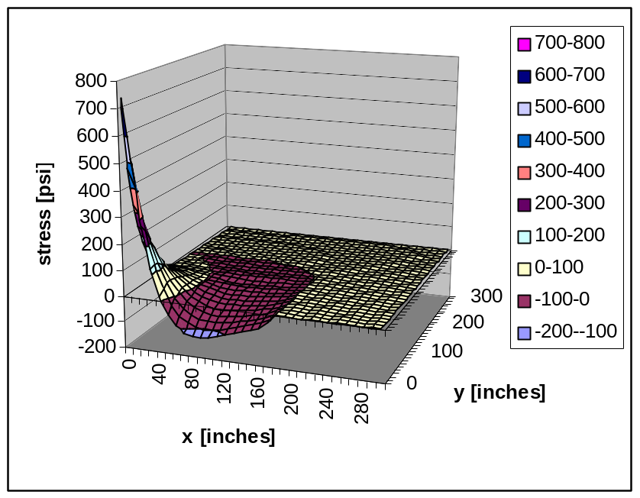

Figure 8. 3-d surface of edge stress depending on wheel position at coordinates x and y (slab thickness = 12.62 inches, coverages = 5,000, and k = 200 pci).

SUMMARY

The FAA has developed a program with multiple purposes including calculation of ACN numbers for aircraft on flexible and rigid pavements and calculation of flexible and rigid pavement thicknesses based on different models. It is a user-friendly tool for airport operators and pavement engineers.

Acknowledgements/Disclaimer

The work described in this paper was supported by the FAA Airport Technology Research and Development Branch, Dr. Satish K. Agrawal, Manager. The contents of the paper reflect the views of the authors, who are responsible for the facts and accuracy of the data presented within. The contents do not necessarily reflect the official views and policies of the FAA. This paper does not constitute a standard, specification, or regulation.

References

- “Aerodrome Design Manual: Part 3 Pavements,” Second Edition, Doc 9157-AN/901 Part 3, International Civil Aviation Organization, 1983.
- “Airport Pavement Design and Evaluation,” AC 150/5320-6D, July 7, 1995.
- Kreger, W.C., “Computerized Aircraft Ground Flotation Analysis-Edge-Loaded Rigid Pavement,” General Dynamics Research Program, Task RDP 414-61-506, January 1967.
- Press, W.H., Flannery B.P., Teukolsky, S.A., and Vettering, W.T., “Numerical Recipes: The Art of Scientific Computing,” Cambridge University Press, 1986.
- R805FAA Computer Program “Computer Aided Design for Rigid Airport Pavements (R805FAA)” Department of Transportation, Federal Aviation Administration, Washington, D.C., May 31, 1988.
- ACNR computer program “ICAO Aircraft Classification Number (ACN) Analysis for Aerodrome Pavements,” International Civil Aviation Organization (ICAO), Aerodromes, Air Routes and Ground Aids Section.
- ACNF computer program “ICAO Aircraft Classification Number (ACN) Analysis for Aerodrome Pavements,” International Civil Aviation Organization (ICAO), Aerodromes, Air Routes and Ground Aids Section.

